Draw as many dfferent triangles as you can, by joining the centre dot and any two of the dots on the edge.
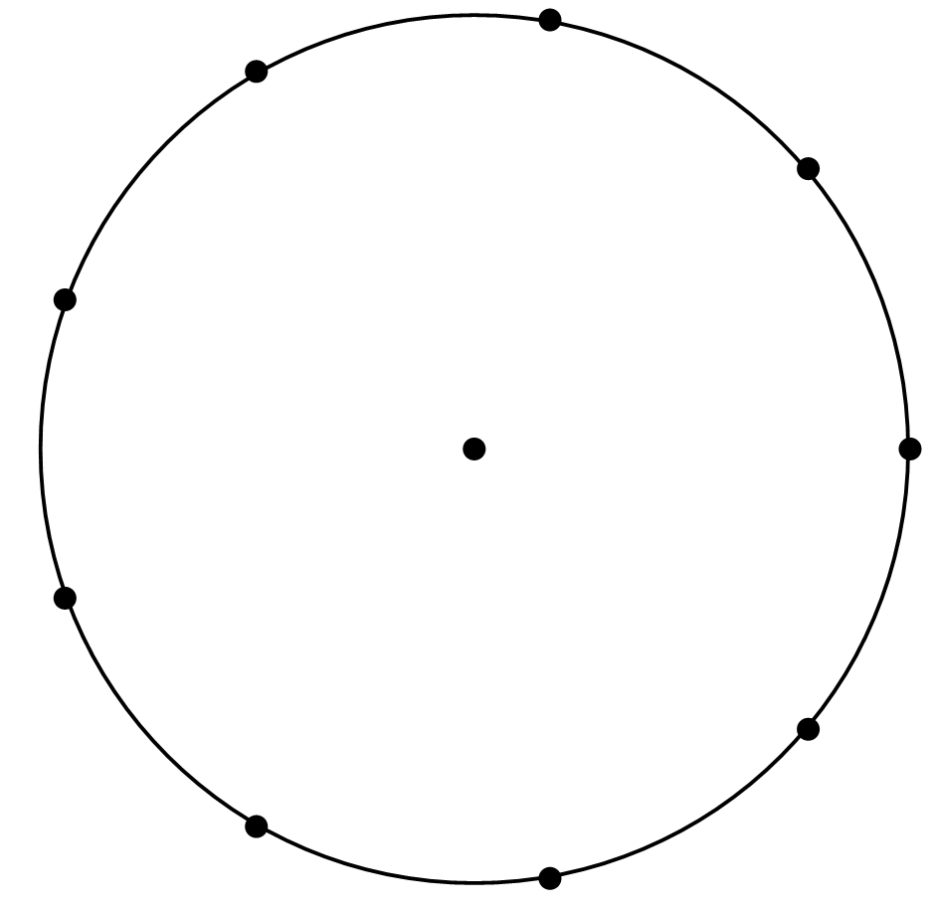
Can you work out the angles in the triangles?

Here is a trangle formed by joining three dots on the edge of the nine-point circle:
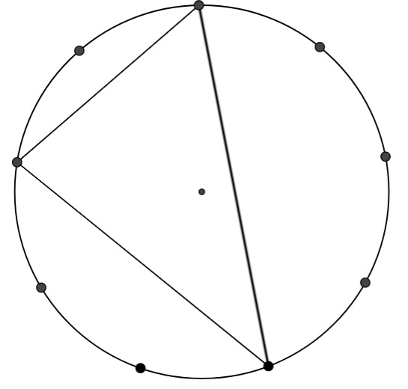
Can you work out the angles of this triangle?
Create some more triangles by joining three dots on the edge of the nine point circle.
How many different triangles can you make?
Can you work out the angles each time?

